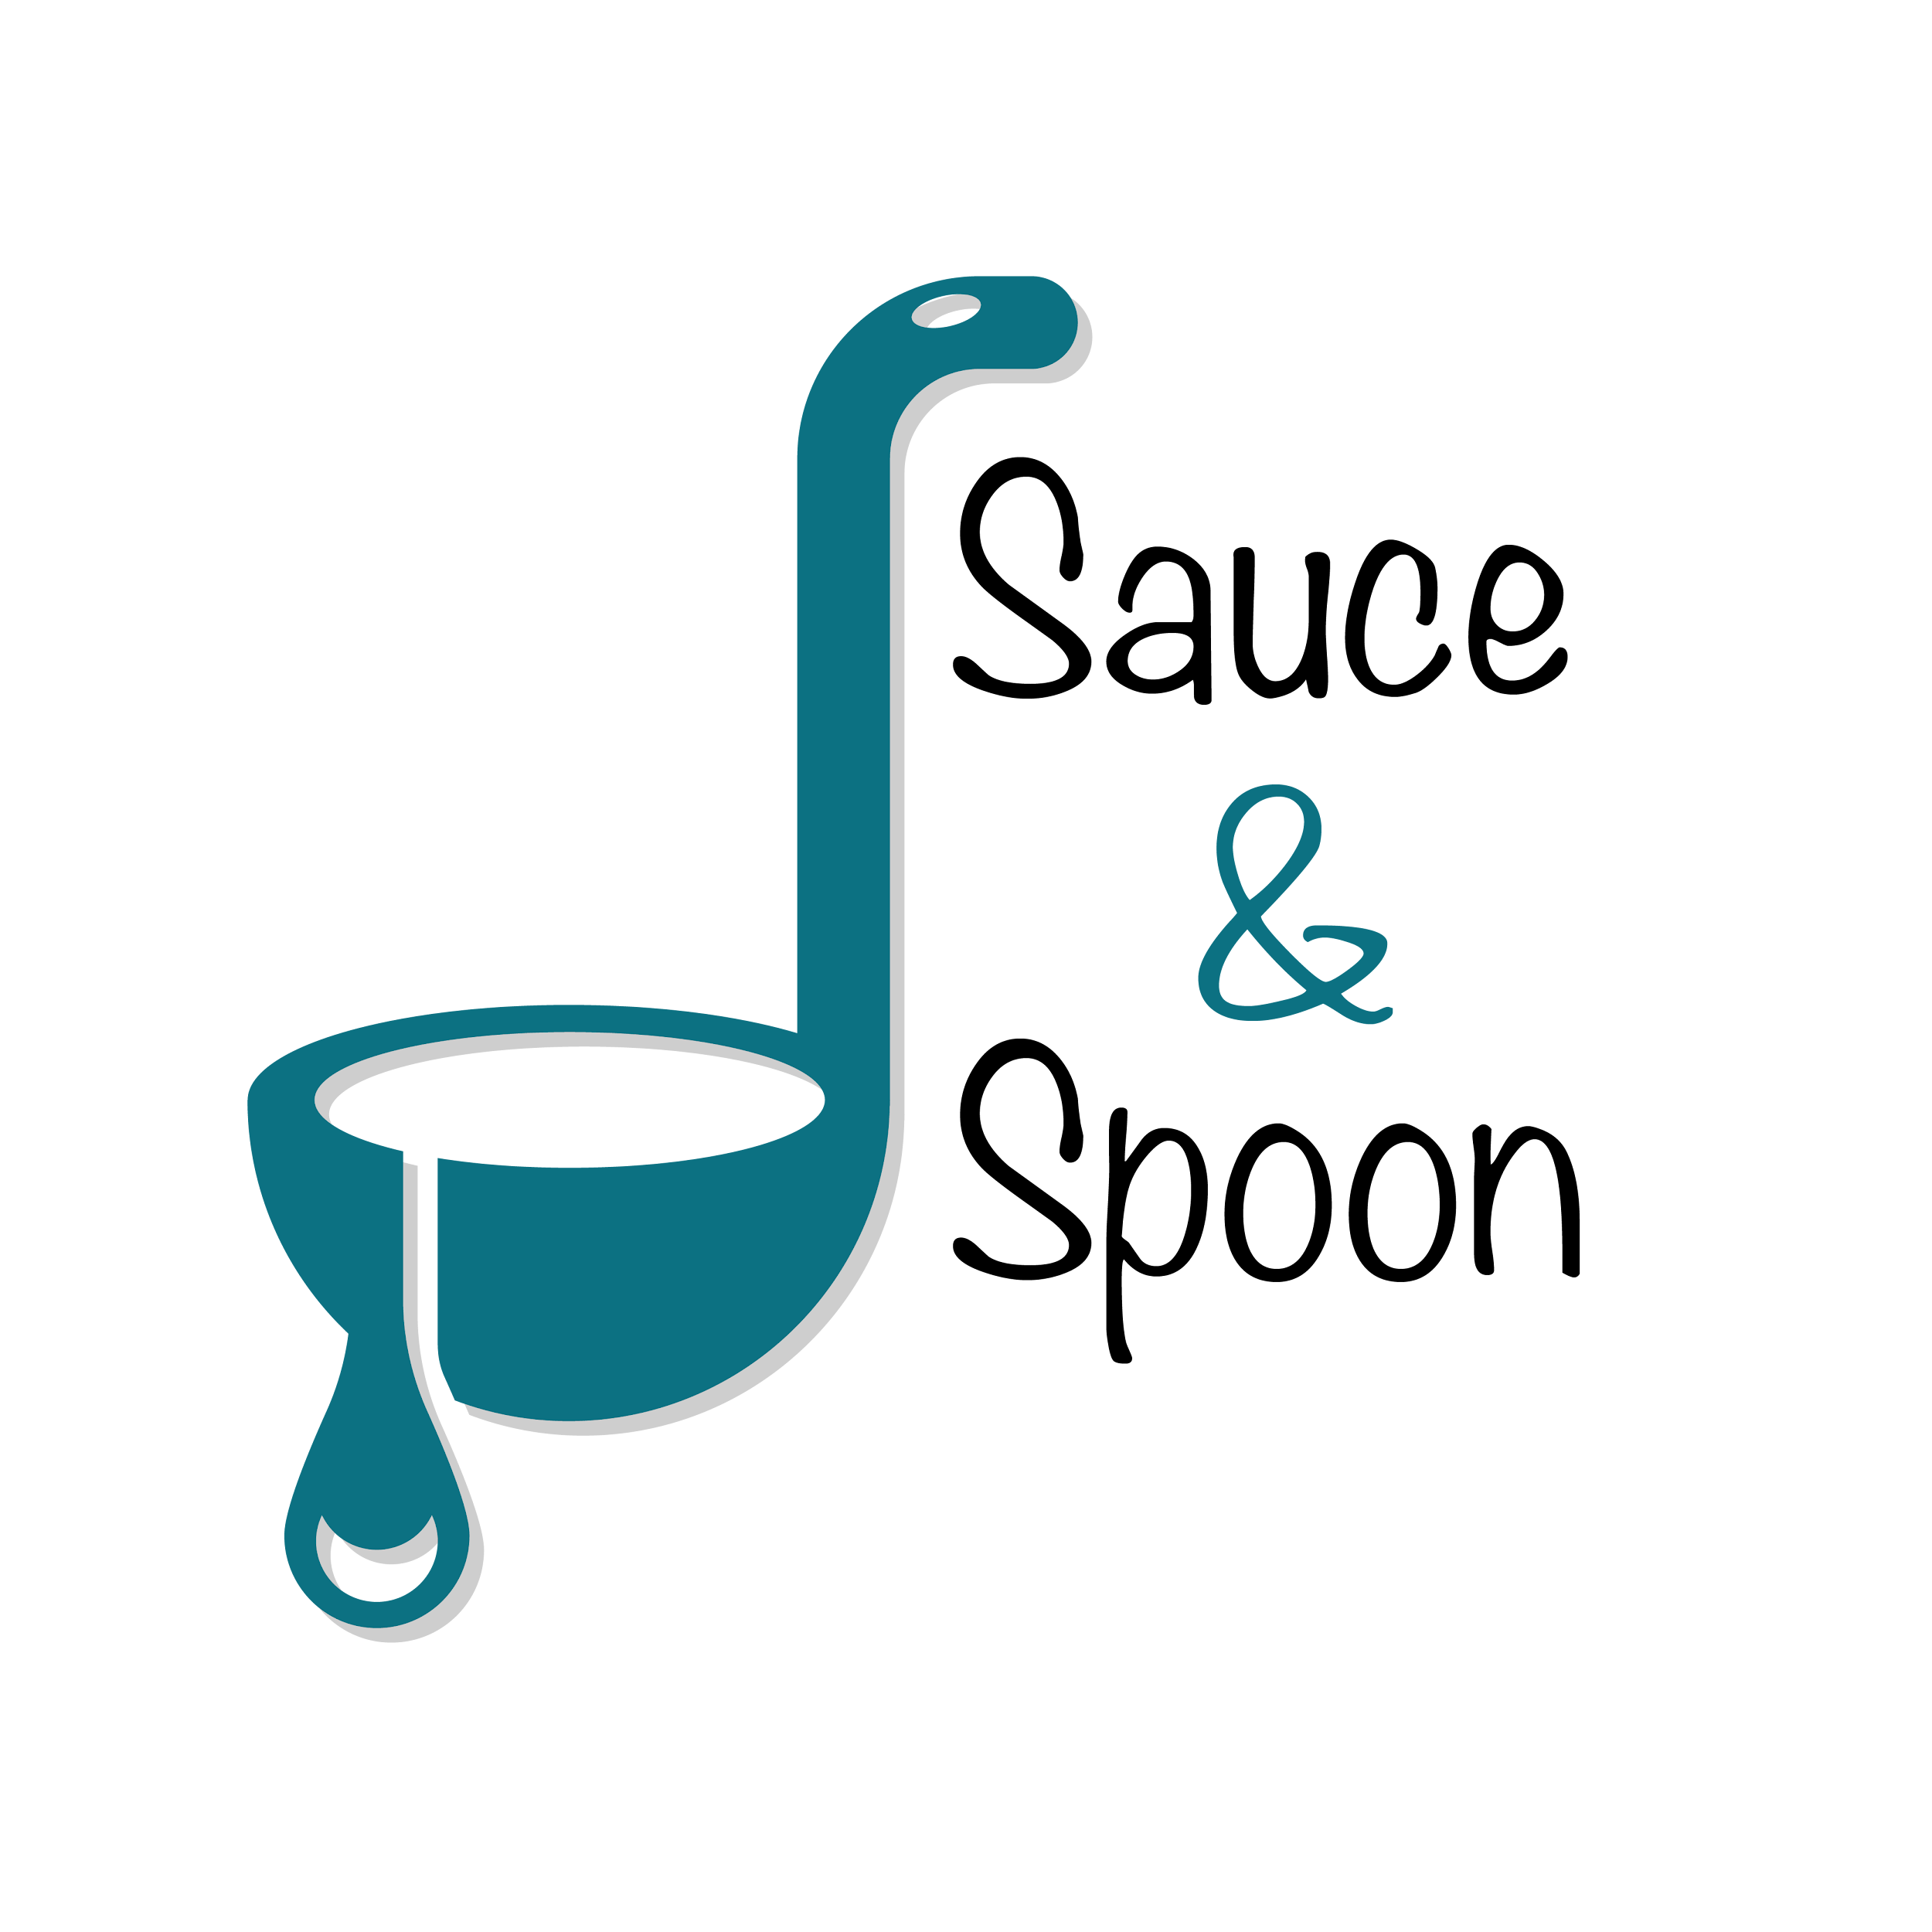

Project Charter: [Sauce & Spoon]

DATE: [11/07/2024]

| **Project Summary** |
| --- |
| Sauce and Spoon launch a pilot project by rolling out tableout menu tablets to assist customers with quick, easy ordering options while providing fresh food for working families of our community. |

| **Project Goals** |
| --- |
| * Digitalize the ordering process and ensure staff training to have a smooth and fast integration * Speed up service, increase table turnover rates, and reduce guest wait times. * Improve table service efficiency by installing tablet menus starting in Q2 * Increase the average check total to $75 by selling more appetizers and beverages by the end of Q2. * Increase the daily guest count by 10% by the end of Q2. * Increase overall appetizer orders by 15% (20% in downtown locations and 10% in the north). * Decrease the average turn time by approximately 30 minutes by the end of Q2. * Reduce employee turnover rate and increase employee satisfaction. |

| **Deliverables** |
| --- |
| * Develop training materials and conduct staff training on the new tablet ordering system. * Include a menu item add-on feature and coupons in the tablet package. * Implement tabletop menu tablets at Downtown and North locations. * Update the website and menu design. * Partner with 5 new local and sustainable vendors each year on a rotating basis. * Ensure tablet software compatibility with the existing system. * Source exclusively from local vendors within a 250-mile radius to support local businesses through sourcing and partnerships. |

| **Scope and Exclusion** |
| --- |
| **In-Scope:**  ● Food waste reduction and order return rate  ● Decreasing table turn time  ● Increasing average daily guest count  ● Staff training  ● Integration of the system with the existing POS system  ● Employee satisfaction  ● Raising check total  **Out-of-Scope:**  ● Implement new policy for food waste  ● Hire more kitchen staff(BoH staff-back of house staff) |

| **Benefits & Costs** |
| --- |
| **Benefits:**  integrated point-of-sale system to help guide decision-making in the future  ● Improve employee royalty  ● Speed up service  ● Increase sales by an estimated percent  ● Provide restaurants with clear data points on customer ordering and an  **Costs:**  ● Training Material - $10,000  ● Hardware and Software Implementation - $30,000  ● Maintenance - $5,000  ● Update Website and Menu Design - $5,000  ● Customization Fee - $550  ● Total : $50,550 |

| **Appendix:** |
| --- |
| * Misalignment about Goal - put decreasing in guest wait time and table turnover   rate as separate goals   * Misalignment about Increase Appetizer Sale as a goal - since different location   got different sale percentage on appetizer and beverage in total sales   * <https://www.coursera.org/learn/applying-project-management/resources/eQdmF> * <https://www.coursera.org/learn/applying-project-management/resources/Ql8xv> * <https://www.coursera.org/learn/applying-project-management/resources/FDWOh> |